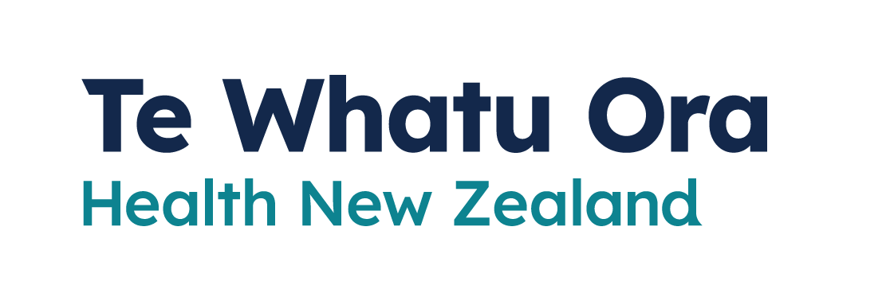
Wearing a
face mask
Adapted in 2023 by Accessible Formats Service,
Blind Low Vision NZ, Auckland
TN: There are two logos at the top of the page. On the left is: Te Kāwanatanga o Aotearoa New Zealand Government. On the right is: Te Whatu Ora
Health New Zealand.

Wearing a face mask
Face masks are a way we can protect ourselves and others. We recommend you wear one when visiting healthcare services and encourage you to wear one when you are in closed, crowded and confined spaces.

You may be asked to wear a face mask
Some healthcare facilities may ask visitors to wear a face mask. This is to protect those at higher risk, for example patients receiving care in an intensive care unit or emergency department of a hospital. To protect those at higher risk, respect and follow the healthcare facilities policies.

Where face masks are recommended
Mask wearing remains an important way we can prevent the spread of COVID-19 and other respiratory illnesses in health and disability care settings.
We recommend you wear a face mask when visiting the following healthcare service providers:
- hospitals—including outpatient services
- hospices
- residential care facilities for older people and people with disabilities
- doctors' clinics
- community and iwi health providers
- pharmacies—excluding pharmacies inside supermarkets
- urgent care services, such as after-hours clinics
- ambulance services
- disability support services
- diagnostic services such as blood testing or radiology services
- dentists and oral health services
- other allied health services such as optometrists, physiotherapists, or chiropractors.
When visiting these healthcare service providers and others, such as psychotherapy, counselling, mental health and addiction services, respect and follow their policies on mask wearing. Healthcare providers may:
- Ask you to wear a mask in particular situations or locations within a healthcare facility to help protect those at higher risk of becoming seriously unwell from COVID-19.
- Continue to require all staff or visitors to wear masks within their facility
- Require mask wearing to comply with Health and Safety obligations.

It is especially important to wear a face mask when visiting people who are at higher risk of becoming seriously unwell. This includes:
- older people and kaumātua
- babies
- people living in aged residential care facilities
- unwell or sick patients in hospital
- people with other health conditions
- disabled people.
If you are infectious and need to visit a healthcare provider to get medical care for yourself, a well-fitting face mask can stop infectious particles from spreading to others, protecting those around you and help to reduce their risk of being infected. It is also a good idea to wear a well-fitting face mask to help prevent you from breathing in infectious particles from others.
Visitors to COVID-19 positive patients need to be aware of the risk to themselves and wear appropriate personal protective equipment. The healthcare facility will advise you on this.
There are times when you should avoid visiting patients or residents of a healthcare facility, such as when you:
- have symptoms of COVID-19 or other infectious illnesses
- have tested positive for COVID-19 in the last 5 days
- are a household contact and are still within your recommended 5-day testing period.
There may be compassionate situations were visiting a patient or resident needs to occur and this should be arranged with the healthcare facility.
If you have tested positive for COVID-19, we recommend you isolate for at least 5 days, even if you only have mild symptoms. After leaving isolation, we recommend you wear a mask for up to 10 days if you need to:
- visit a healthcare facility
- visit an aged residential care facility
- have contact with anyone at risk of getting seriously unwell with COVID-19
This is because some people are infectious for up to 10 days. Some healthcare facilities may continue to require all staff or visitors to wear masks regardless of whether there have recently had COVID-19. To protect those at higher risk, respect and follow the healthcare facilities policies.

Where face masks are encouraged
We encourage you to wear a face mask if you are:
- a Household Contact and testing daily for 5 days
- at higher risk of getting seriously ill from COVID-19
- keen to reduce your risk of becoming sick.
We also encourage you to wear a face mask in these places:
- public transport, including buses, commuter trains, indoors on ferries, flights, taxis and ride-shares
- crowded places
- enclosed spaces with poor ventilation
- during close contact situations, such as face-to-face conversations.
Some places may still ask you to wear a face mask. This is their decision and no longer a government requirement.

Free face masks
You can get free face masks when you pick up free rapid antigen tests (RATs) from participating collection sites. You do not need to be unwell or have COVID-19 symptoms.
Find a collection centre near you on the Healthpoint website, or by calling 0800 222 478 and choosing option 1.
To find a testing site that offers free face masks, go here: www.covid19.govt.nz/FreeFaceMasks
If you are at higher risk of severe illness, you can get free P2/N95 face masks.

People who may not be able to wear a face mask
Face masks are unsuitable for some people.
Children aged 5 or under are generally not recommended to wear a face mask.
Children between 6 to 11 years of age are encouraged to wear a mask at the discretion and supervision of their caregiver.
People who have a health condition or disability that makes wearing a mask unsuitable are generally not recommended to wear a mask.
If you cannot wear a face mask, you should keep up the healthy habits we know to keep you and others safe. They include:
- staying home if you are sick
- keep your distance from others
- wash your hands often
- cough and sneeze into your elbow.

If you need support
- The COVID-19 disability helpline can provide help or information about vaccines, face mask exemptions, testing, managing COVID-19, and any other health concerns you may have.
Call 0800 11 12 13 for free. If you are unable to call, you can text 8988.
- The COVID-19 welfare phone line can help if you are self-isolating and need food or other essential items. Call 0800 512 337.
- You can also call Healthline for free for advice on
0800 358 5453.
End of Wearing a face mask

