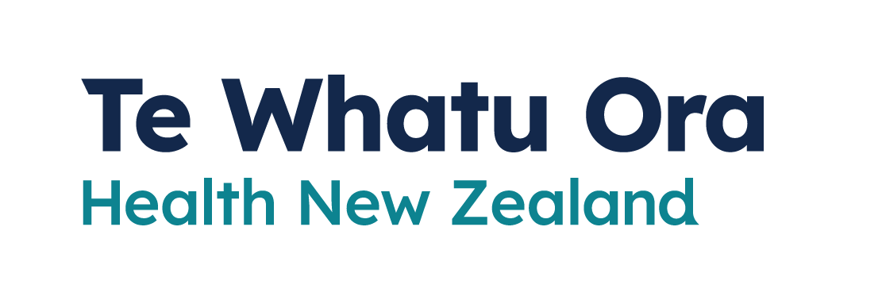
COVID-19 Vaccination
Adapted in 2023 by Accessible Formats Service,
Blind Low Vision NZ, Auckland
TN: There are two logos at the top of the page. On the left is: Te Kāwanatanga o Aotearoa New Zealand Government. On the right is: Te Whatu Ora
Health New Zealand.

COVID-19 Vaccination
Everyone in Aotearoa New Zealand aged 5 and over can get a free COVID-19 vaccine now. You can get a booster if you are aged 16 or over.

Who can get a COVID-19 vaccine
Everyone in New Zealand aged 5 or over can get a free COVID-19 vaccination. It does not matter what your visa or citizenship status is.
Children aged 6 months to 4 years can get the paediatric Pfizer vaccine if they are at higher risk of severe illness from COVID-19.

Which vaccine you will get
Pfizer is the preferred COVID-19 vaccine for use in New Zealand.
If you are 18 years of age or older and either cannot get the Pfizer vaccine or want a different option, you can get the Novavax vaccine.
You will be given the option to choose your vaccine type when you book. The Novavax vaccine is not available at all vaccination sites.
Whichever vaccine you get, you will need 2 doses. COVID-19 vaccines are free.

Side effects
Like all medicines, you might experience some mild side effects in the days after getting your vaccination. This is common, and a sign that your body is learning to fight the virus.
Most side effects do not last long, and will not stop you from having a second dose or going about your daily life. Some side effects may temporarily affect your ability to drive or use machinery.
The most common reported reactions are:
- pain or swelling at the injection site
- feeling tired or fatigued
- headache
- muscle aches
- chills
- joint pain
- fever
- redness at the injection site
- nausea
Some side effects are more serious but rare, such as a severe allergic reaction.
Serious allergic reactions or anaphylaxis from the vaccine are rare. This is why people are watched for around 15 minutes post-vaccination. Vaccinators are well trained in managing these if they occur.

Booster doses
Having COVID-19 does not provide the same level of immunity as getting vaccinated. We also know that your protection from the primary course of the vaccine decreases over time.
To keep your immunity levels high, stay up to date with your vaccinations—including boosters. This will lower your chances of getting very sick from COVID-19 and ending up in hospital.
Boosters provide an extra layer of protection to previous vaccination and help your immunity be stronger and last longer. The Pfizer BA.4/5 bivalent vaccine is now the vaccine used for boosters.

If you are 30 years of age and over
If you are 30 years of age and over, you can have a booster regardless of the number of boosters you have already had.
You can have a booster if:
- you had your first 2 COVID-19 vaccinations (your primary course)
- it is recommended you wait at least 6 months since you had COVID-19
- it is recommended you wait at least 6 months since you had any other COVID-19 vaccine.

If you are 16 to 29 years of age
Healthy people aged 16 to 29 can have a 1 booster dose.
To get a booster:
- you must have had at least your first 2 COVID-19 vaccinations, and
- it is recommended you wait at least 6 months since your last COVID-19 vaccine or infection.
Some people aged 16 to 29 can have an additional booster dose. This includes:
- severely immunocompromised people
- pregnant people
- those who have a medical condition that increases the risk of severe illness from COVID-19
- those who live with disability with significant or complex health needs or multiple comorbidities.

If you are 12 to 15 years old
Healthy children under 16 years old are not eligible for boosters.
Young people aged 12 to 15 who have a medical condition that increases the risk of severe illness from COVID-19 can get a booster dose on prescription. Talk to your doctor, nurse, or healthcare provider about whether this is recommended and how to get a prescription.

Children under 12 years old
Children under the age of 12 cannot get a booster.
You can talk to your doctor, nurse or healthcare provider about your child's specific circumstances.
Children have a good immune response and are much less likely to have a severe illness and need to go to hospital if they get COVID-19.

How to get a COVID-19 vaccination

Book online
It is free, fast and easy to book or change your appointments using the website Book My Vaccine.
Before you book, check the appointment availability map. It can show you where vaccination sites are, how soon you can get an appointment, and which vaccine types are available.
To book a COVID-19 vaccination online, go here: It is free, fast and easy to book or change your appointments using the website Book My Vaccine.
Before you book, check the appointment availability map. It can show you where vaccination sites are, how soon you can get an appointment, and which vaccine types are available.
To book a COVID-19 vaccination online, go here: www.BookMyVaccine.nz
If you have problems booking or need to change your details, email booking@vaccine.covid19.health.nz

Book over the phone
The COVID-19 Vaccination Healthline is available from 8am to 8pm, 7 days a week.
You can ask for an interpreter if you need one.
Call: 0800 28 29 26

Walk-ins
There are many places around New Zealand where you can get a COVID-19 vaccine without an appointment.
To find a walk-in vaccination centre, go here: www.covid19.govt.nz/WalkInVaccination

If you need support
- The COVID-19 disability helpline can provide help or information about vaccines, face mask exemptions, testing, managing COVID-19, and any other health concerns you may have.
Call 0800 11 12 13 for free. If you are unable to call, you can text 8988.
- The COVID-19 welfare phone line can help if you are self-isolating and need food or other essential items. Call 0800 512 337.
- You can also call the Vaccination Healthline for free for advice on 0800 28 29 26 (8am-8pm 7 days a week).
End of COVID-19 Vaccination

